**Ulric Aird**

**A1 Take Home Assignment**

This reflective paper is based on the take home assignment 1. While doing this paper, I will explain the things I did and how it shaped the way I think towards networking and in the process, gather the various knowledge I have gotten from this assignment.

Creating a network topology in Cisco Packet Tracer is surprisingly very easy and simple. It gives a demonstration of how the network topology works in the real world. At first, when I learned about Packet Tracer and network topology, it was really challenging, but as time went on, it became easy and understandable. When doing the assignment, I opened Cisco Packet Tracer and got started with the assignment. I added a router, a switch, some pcs, and some laptops to the workspace. Then I managed to connect it using the “Automatic Choose Connection Type” feature that Cisco Packet Tracer offers. This feature will automatically choose a connection type for you when you connect the devices to the switch. I also added an extra laptop to simulate the wireless feature. I then proceeded to configure each device by adding an IP address and a subnet mask address which can be listed in the table below. After I was done with this, I got started with troubleshooting. I tested it by sending a “PDU” from each device to another device. When testing laptop 3, (the laptop that used wireless feature), it failed, but when I tested it again it was successful. This experience has taught me how stuff works, despite the failures it has come with and the steps it takes to solve them.

To sum up this assignment, I have learned to be patient when dealing with errors and it has also taught me some general skills such as computer skills and problem-solving skills. I will use this experience to reflect on the things that I hope to accomplish in the future.

|  |  |  |  |
| --- | --- | --- | --- |
| Devices Name | IP Address | Subnet Mask | Default Gateway |
| Router | 192.168.0.1 | 255.255.255.0 | 192.168.0.1 |
| PC 1 | 192.168.0.2 | 255.255.255.0 | 192.168.0.1 |
| PC 2 | 192.168.0.3 | 255.255.255.0 | 192.168.0.1 |
| Laptop 1 | 192.168.0.4 | 255.255.255.0 | 192.168.0.1 |
| Laptop 2 | 192.168.0.5 | 255.255.255.0 | 192.168.0.1 |
| Laptop 3 | 192.168.0.6 | 255.255.255.0 | 192.168.0.1 |

Table with IP Address

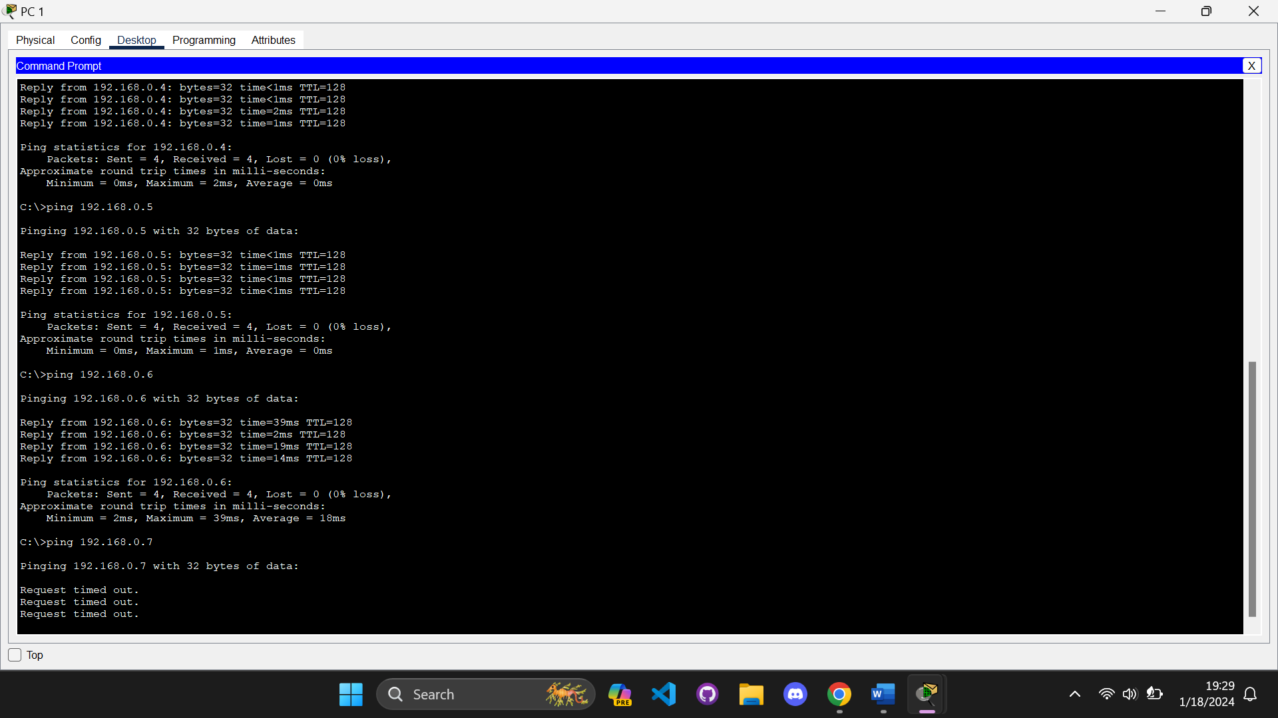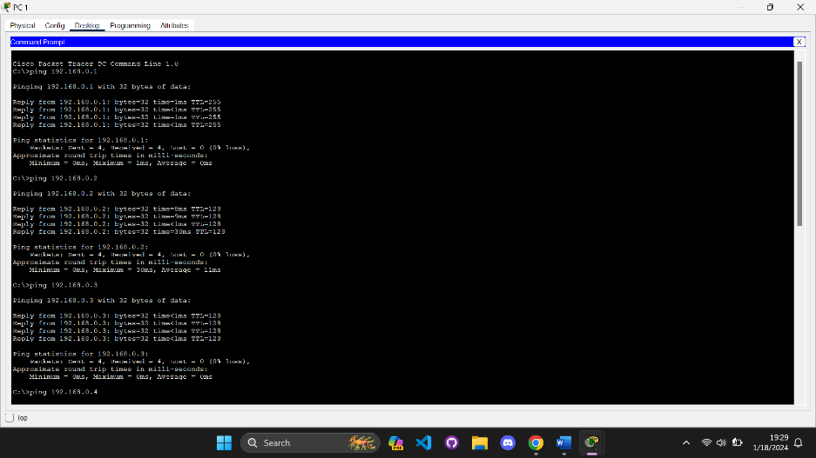**Ping Test: PC 1**

**Ping Test: PC 2**

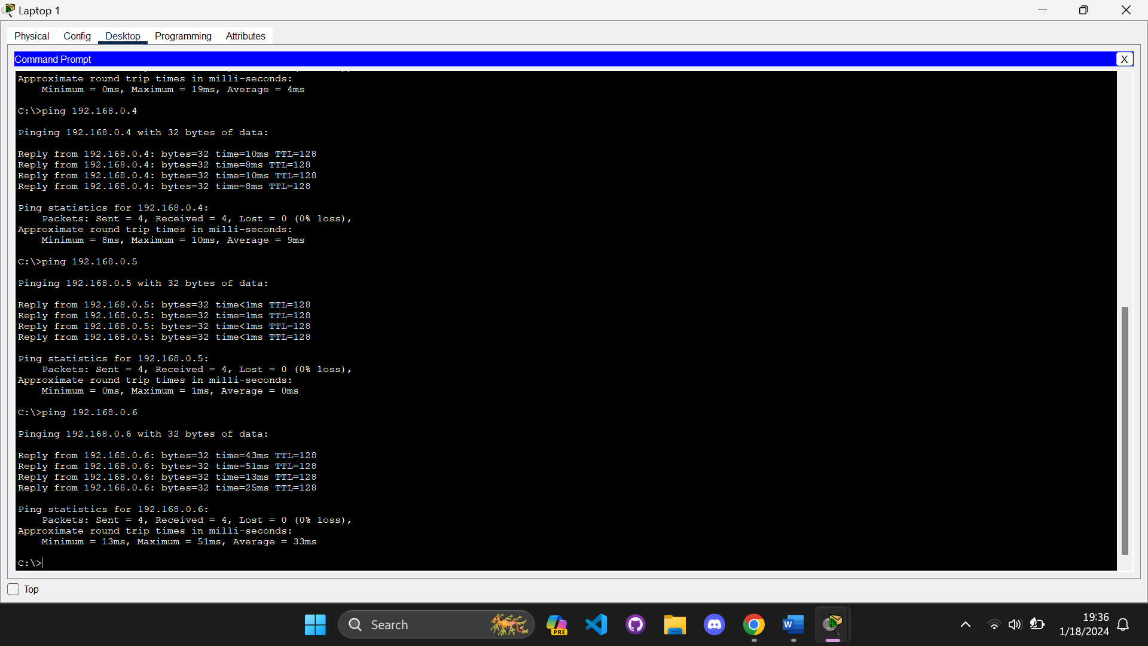**Ping Test: Laptop 1**

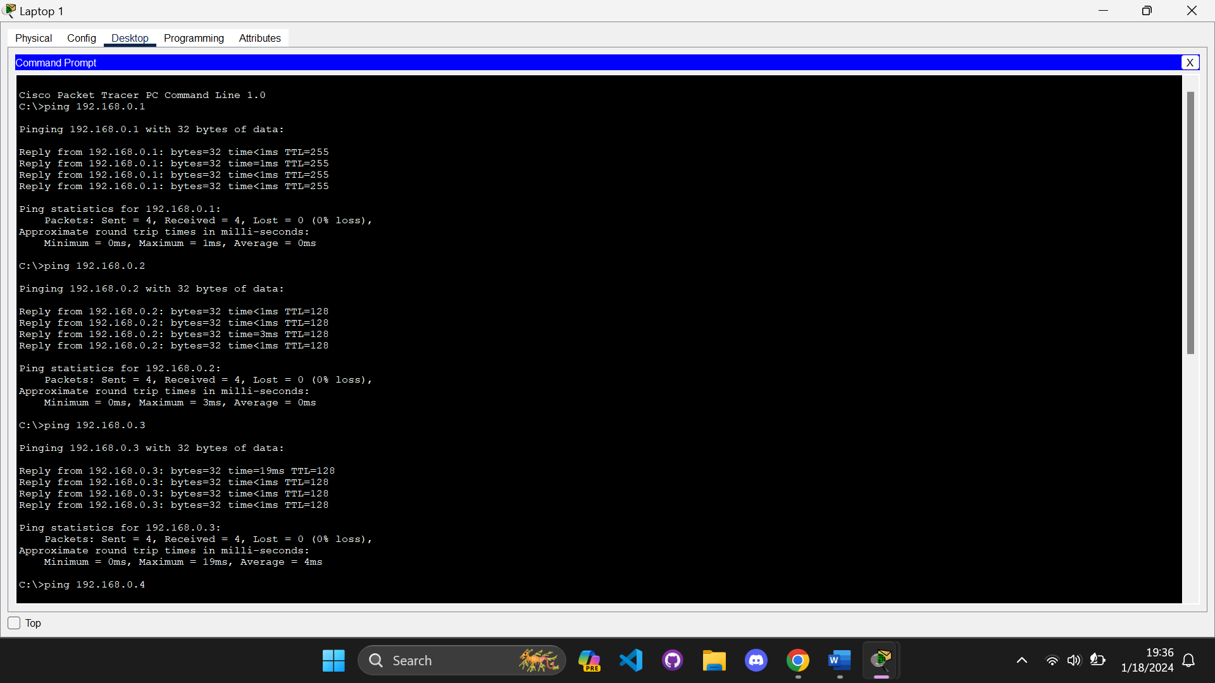

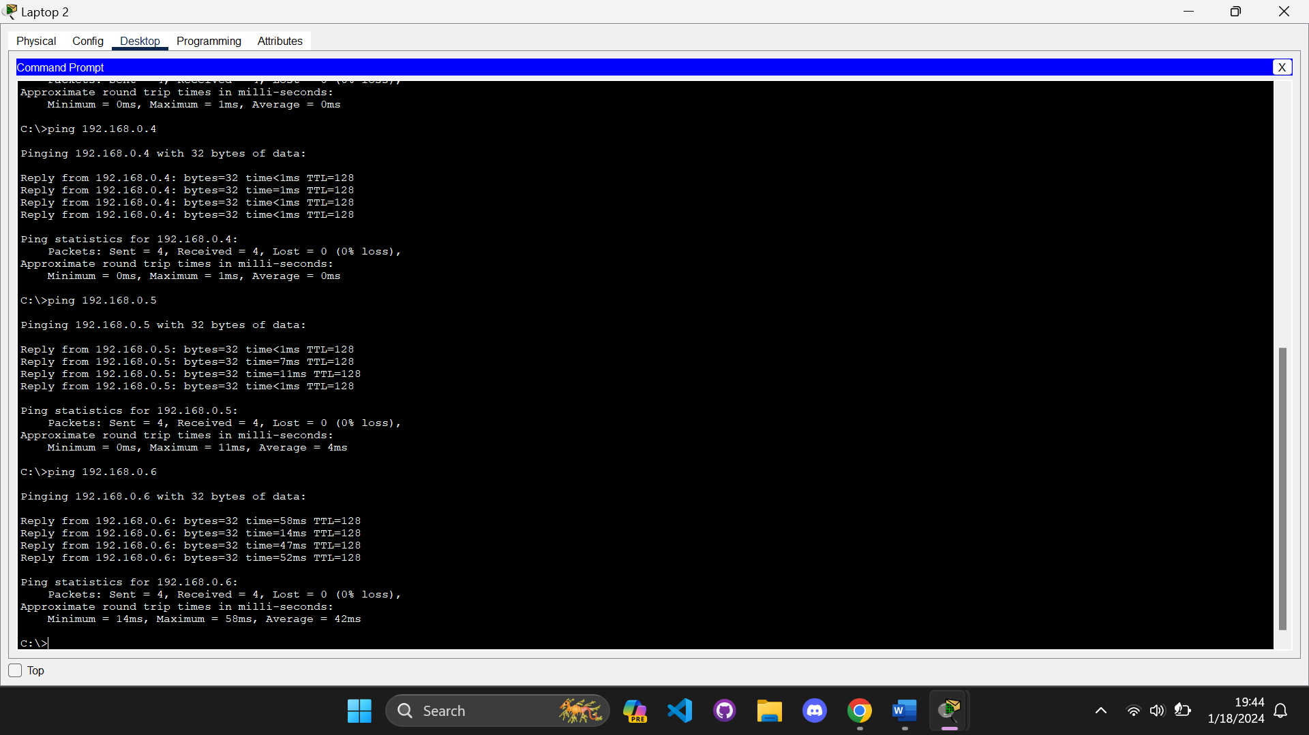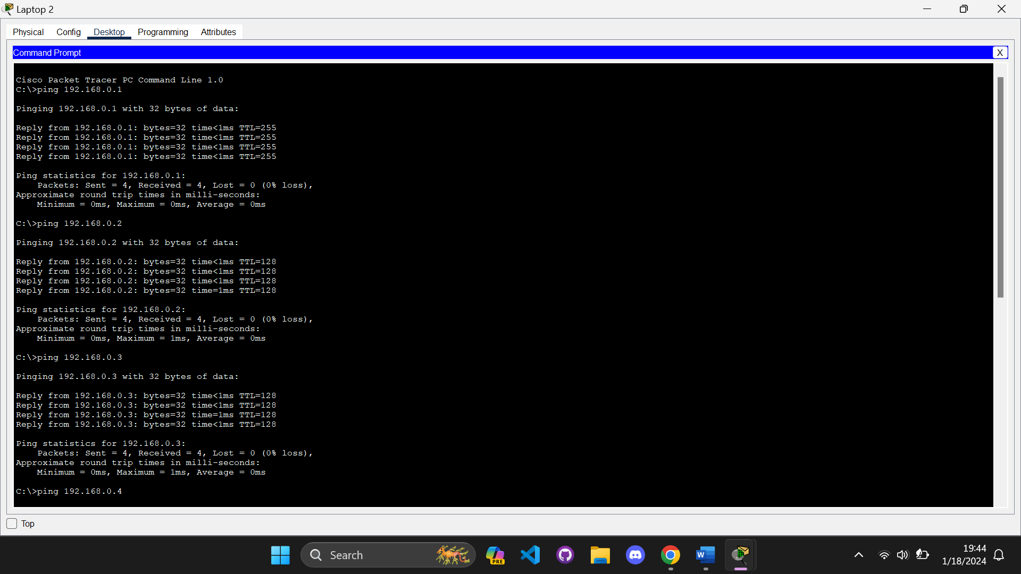**Ping Test: Laptop 2**

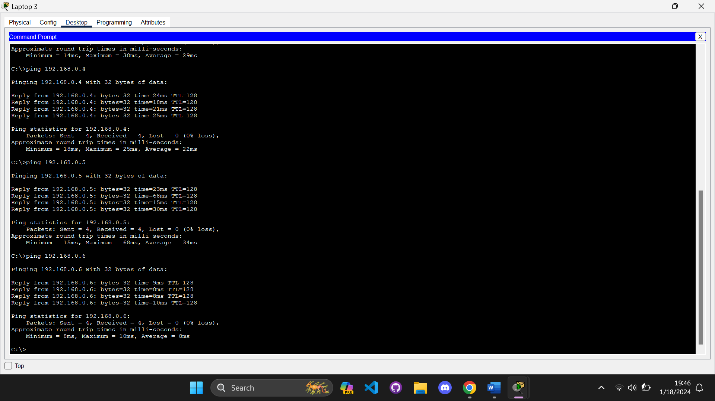**Ping Test (Wireless): Laptop 3**

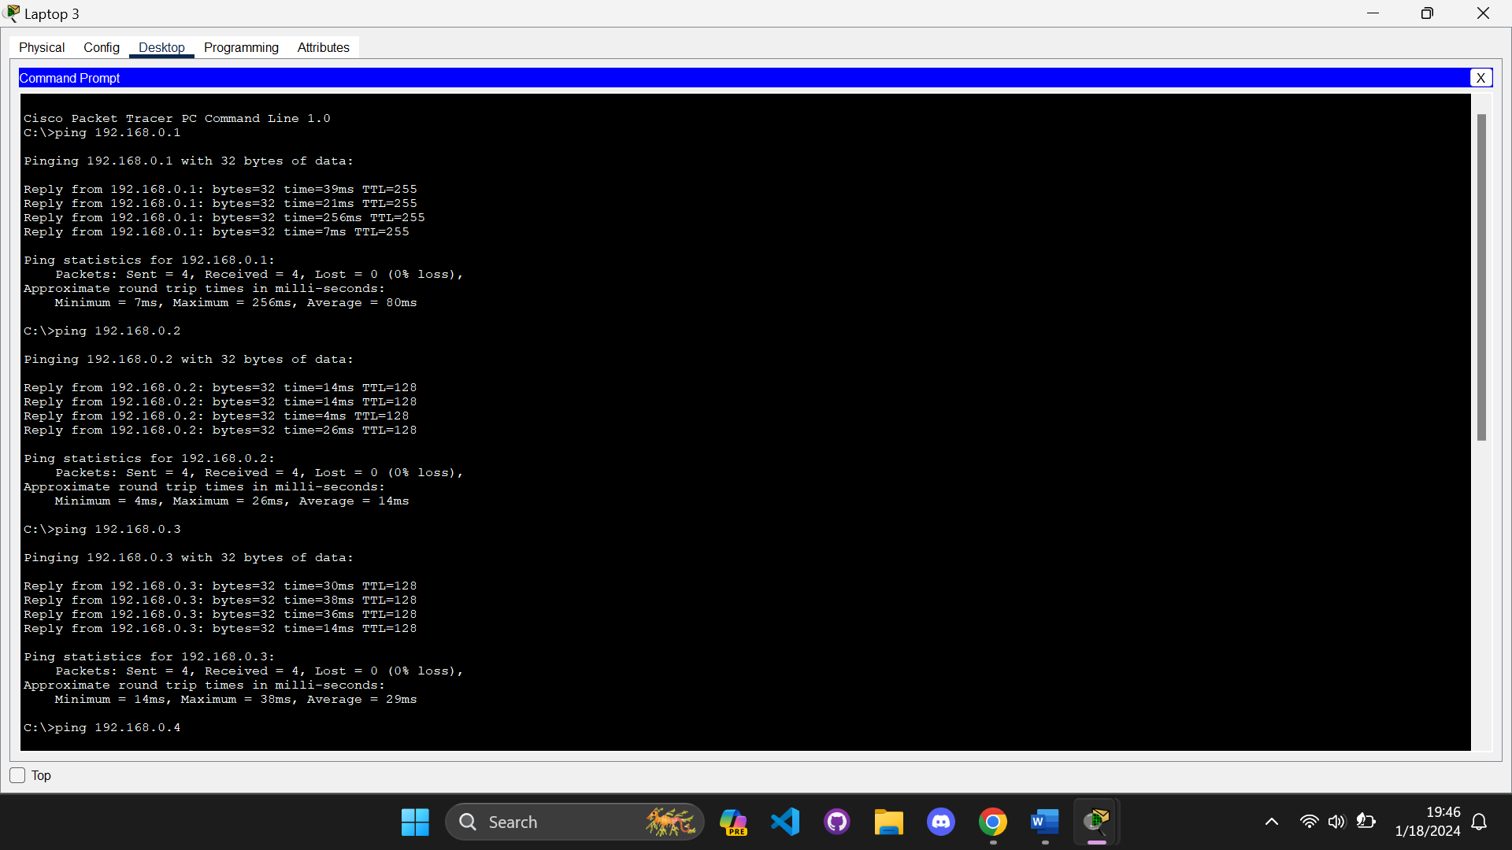

**PDU Test**

